Weston King Neighbourhood Centre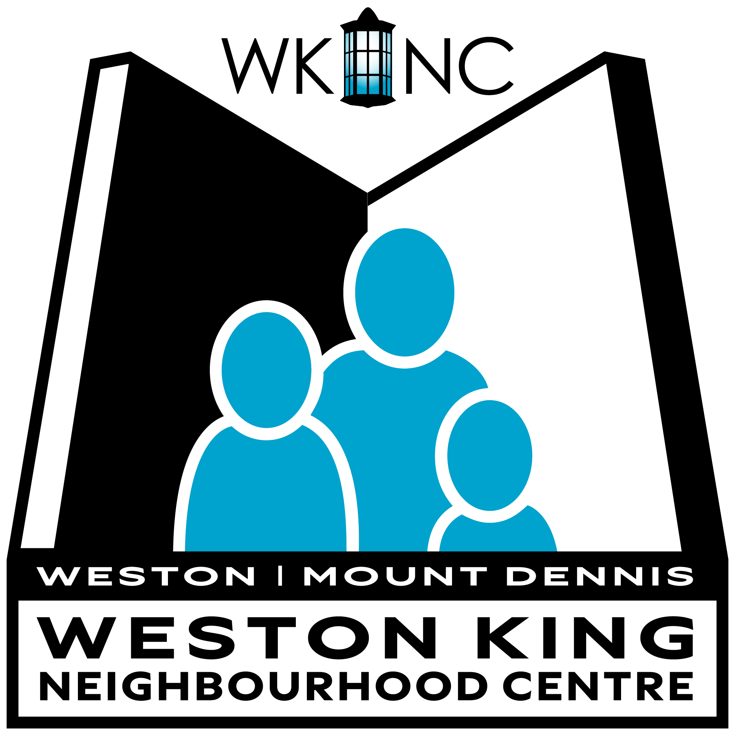

2024 AGM

Tuesday, June 17, 2025, 7:00 PM

2017 Weston Road, Weston, ON

[Zoom Link](https://us06web.zoom.us/j/87019944354?pwd=OM1PJHbqyPTvoZgkxrqUcOnacXT3cB.1) for those who cannot attend in person

# Agenda

1. Welcome & Land Acknowledgement
2. Greetings from the Chair
3. Appointment of Secretary
4. Guest Speakers: Frances Nunziata, Toronto City Councillor & Rikki LaCoste, WKNC Board Member
5. Motion for approval of the agenda
6. Motion for approval of the [2023 AGM minutes](https://docs.google.com/document/d/1BDX-Jot3URvgYrxV1sXlsTFe5psWHlaa5_ufjsANlHE/edit?usp=sharing)
7. Motion for approval of [financial audited report](https://drive.google.com/file/d/1mGKU0p0JSKgDK4RQwcsXsi9EWwXqhLC3/view?usp=sharing)
8. Motion for appointment of auditor for 2025
9. Motion for approval of [bylaw amendments](https://docs.google.com/document/d/1L97RJucoPVAjRIENl4zYSxlMvmUe3F8uGKEq1WBmNUk/edit?usp=sharing)
10. Motion to elect Board of Directors
11. Motion to confirm acts of the Directors
12. Close Meeting